## WELCOME

Thank you very much for choosing our products!

The data package we provide is a zip compression package. Please unzip the data package before learning. Start from this PDF course.

## **Technical support**

If you have any questions about the product, don't worry. You can view the "Common problem.PDF" file or contact us.

Our email is [straysnail-wiki@outlook.com](mailto:straysnail-wiki@outlook.com)

We will reply you within one working day and give you a reasonable solution.

## Safety matters

* This product is recommended for children over 6 years old.
* This product needs battery power supply. It is not waterproof. Don't play in water.
* Turn off the power switch when not in use.

## About Stray Snail

* Stray Snail is the brand trademark of Shenzhen Snail Man Intelligent Technology Co., Ltd.
* Mainly for STEAM education products, self developed, including hardware and software design.
* The main products are smart cars, 3D printers and DIY writing plotters, mechanical arms, and some e-learning kits.
* The main control board includes Arduino, raspberry pie, Micro-bit and ESP series.
* Provide customization services: hardware customization, such as the design of sensor modules or the entire product.
* Software customization: Bluetooth and WiFi control APP of Android and iOS, and secondary development customization of scratch3.0 graphical programming.

If you want to know more about Stray Snail, you can visit our official website:

<https://www.straysnail.com>

## Copyright

Our product design is patented, and trademarks, materials and software are released under CC agreement.

CC protocol is《Attribution-ShareAlike 3.0 Unported》.That is, it cannot be used for commercial purposes without our permission.

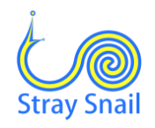

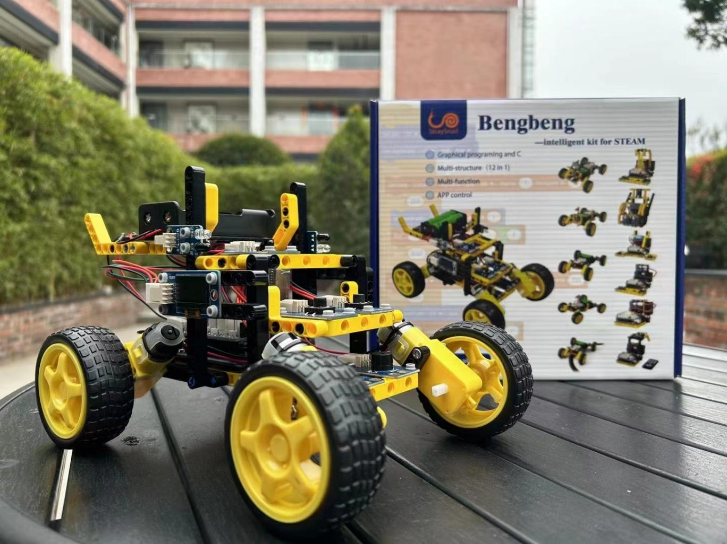

## Ⅰ. Introduction of BENGBENG

The invention of building blocks is so creative that a stable and innovative structure can be installed without using a screw. Isn't it the perfect match for STEAM education? Therefore, we designed some sensor modules, and skillfully used PMMA boards with holes, which are compatible with building blocks, to create a building block car -- BENGBENG.

However, the idea of building blocks is flexible and should not be limited to one structure. So we have designed and assembled 12 structures by using the existing components. And corresponding to these structures, teaching documents of 12 courses have been prepared.

In terms of programming language, SnailBlock, a graphical programming software compatible with scratch 3.0, is used to write programs like building blocks, making programming easier for younger children to learn.

Of course, functions are also very rich, including tracking, following, mobile phone control, infrared remote control, music box, etc, which are very interesting.

Hands on practice and creative programming are so attractive. Let's happily learn about the programming robots.

## Ⅱ. **Product features**

* Use building blocks to build the structure without using a screwdriver.
* 12 structural construction tutorials.
* Graphical programming tutorial, just like building blocks, is simple and easy to understand.
* Functions are rich, including tracking, obstacle avoiding, turning and following, music box, etc.
* It can be controlled by iOS and Android APP.

## Ⅲ. **Products parameters**

Input voltage of USB interface of Arduino UNO main board : 5V

Input voltage of external power interface : 7~12.6V

Working voltage of all sensor modules : 5V

The illustration of Arduino UNO main board is as follows :

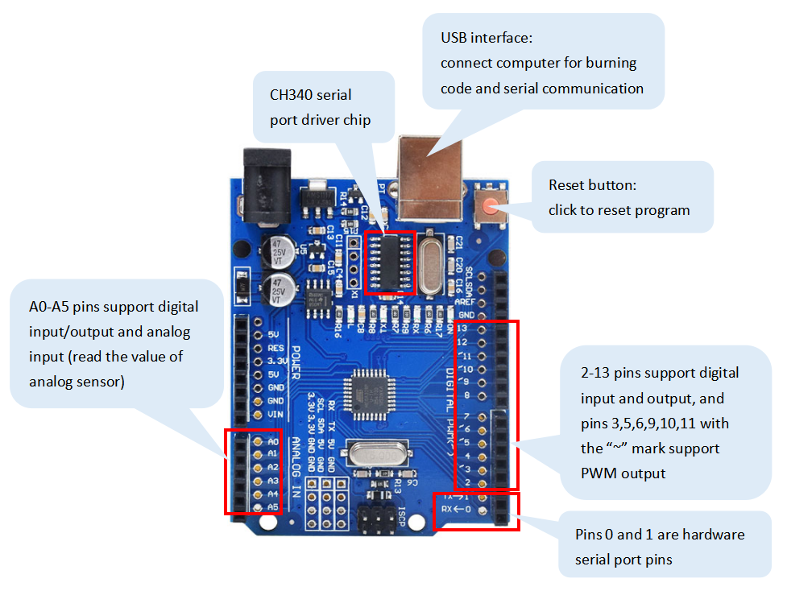

The illustration of expansion board is as follows:

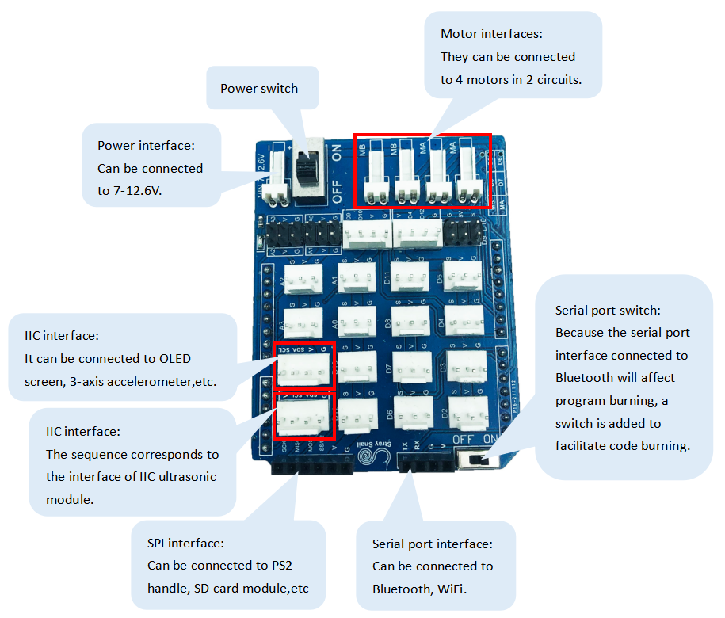

## Ⅳ. **Software and its environment configuration**

### 1. Install Arduino IDE and serial port driver

Please open the learning manual of SnailBlock graphical programming software provided by us.

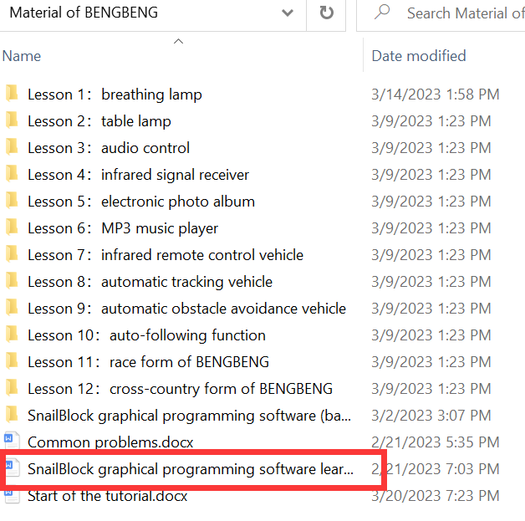

## Ⅴ. **Learn to control BENGBENG**

The BENGBENG learning kit has 12 structures in total. Each structure is a major course, from simple to complex. Follow our tutorial to learn, and I believe you can master the knowledge of each function.

